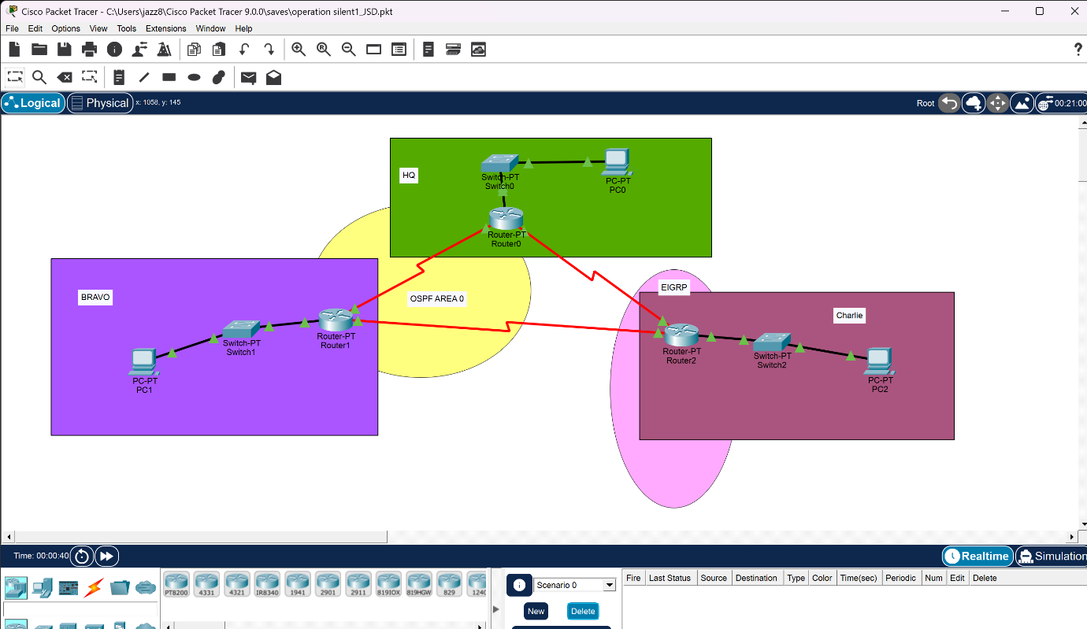
LAYOUT OF NETWORK

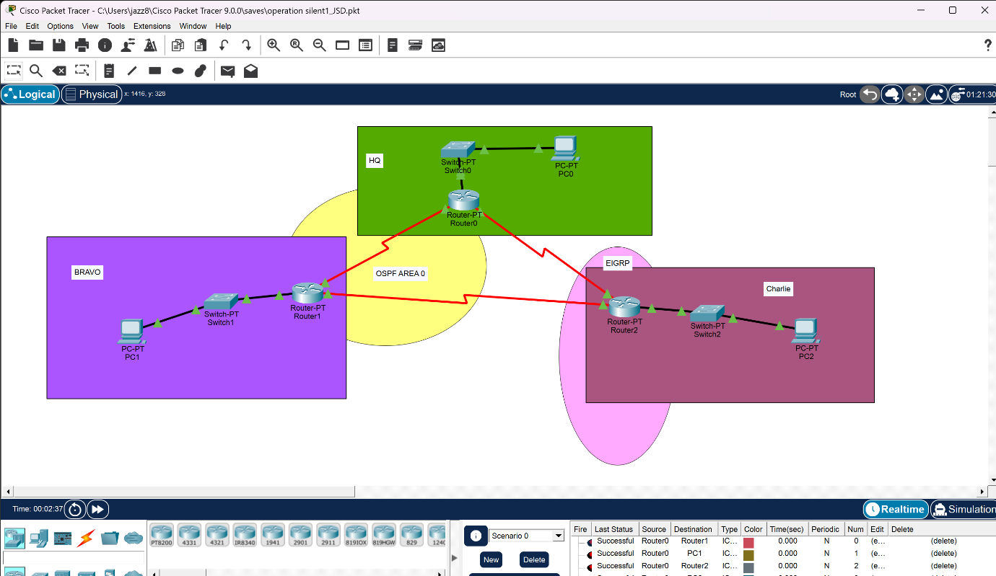
WITH SUCCESSFUL PING BETWEEN NETWORKS

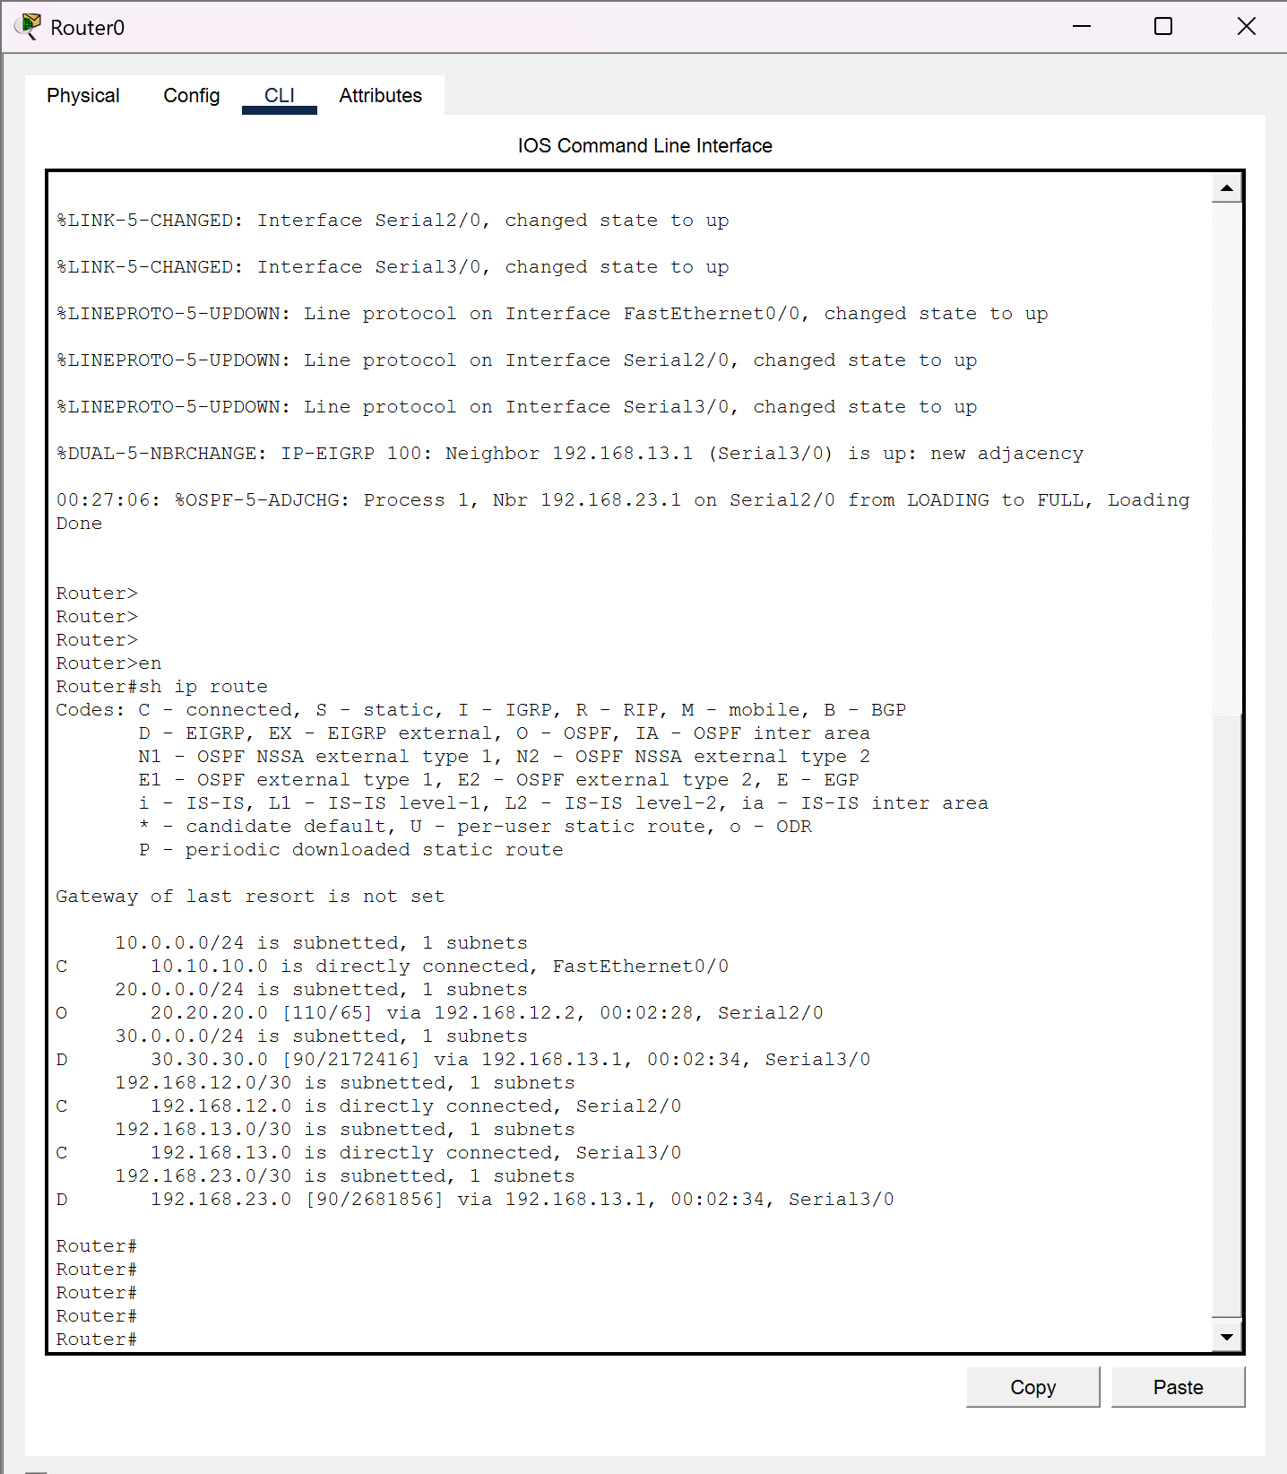
ROUTING TABLE OF HQ ROUTER

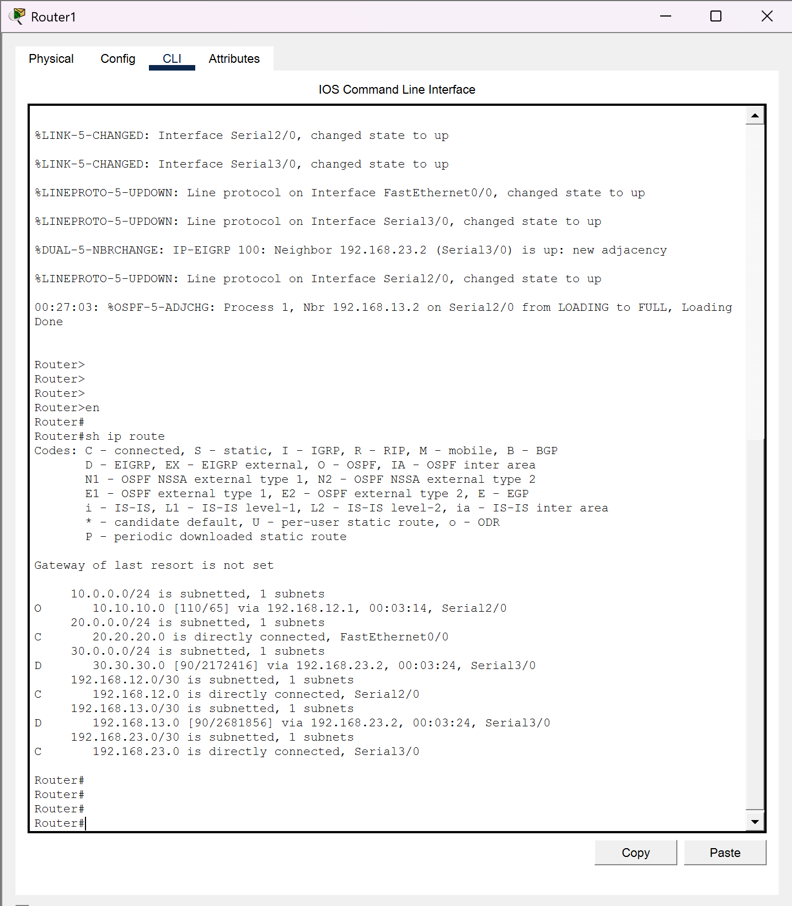
ROUTING TABLE OF BRAVO ROUTER

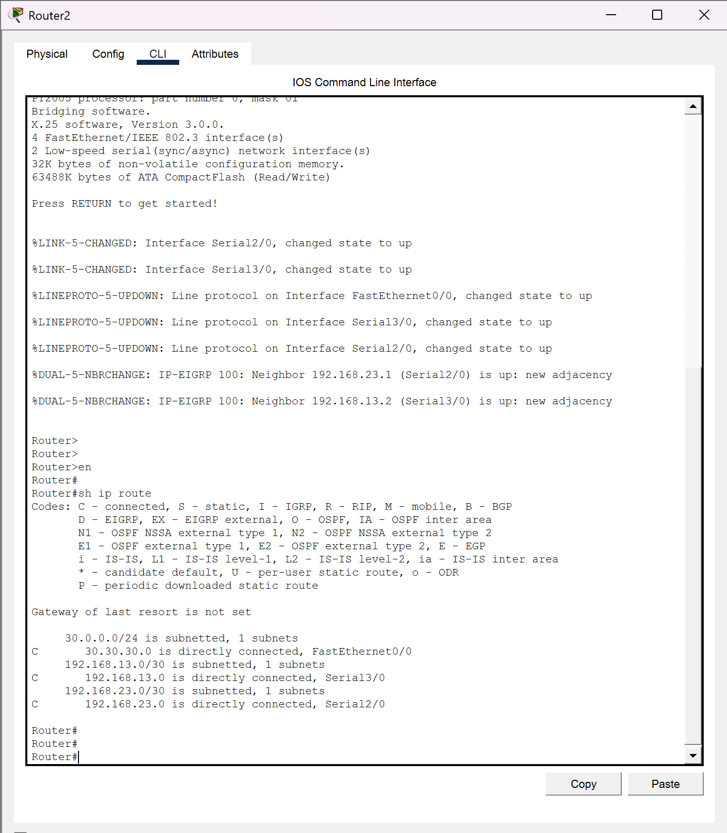
ROUTING TABLE OF CHARLIE ROUTER

